BSCS FINAL PROJECT PROPOSAL
Rapid Rescue

Fall 2024



Presented by:
Registration No: | Name:
L1F21BSCS1039 | TALHA JAVED
L1S21BSCS0105 | FAHEEM KHAN
L1F21BSCS1214 | JAWAD AHMAD

Faculty of Information Technology
University of Central Punjab
Project Title
Rapid Rescue: Ambulance Dispatch Analytics and Optimization through AI with Real-Time Video

Project Advisor
Asif Farooq

Particulars of the students:
Sr. # | Registration# | Name in Full  Use Block Letters | CGPA | Signature
1 | L1S21BSCS0105 | FAHEEM KHAN | 3.06
2 | L1F21BSCS1039 | TALHA JAVED | 3.15
3 | L1F21BSCS1214 | JAWAD AHMAD | 3.42

Advisor’s Consent
I Prof./Dr./Mr./Ms. ________________________________________________ am willing to guide these students in all phases of above-mentioned project as advisor. I have carefully seen the Title and description of the project and believe that it is of an appropriate difficulty level for the number of students named above.

Note:  Advisor can’t be changed without prior permission of the Manager Projects and the duration for completion of the Project is 2 regular semesters (approx.) from the date of Registration of Research Project. | Signatures and Date  Advisor
EVALUATOR/REFEREE 1
I have carefully read the project proposal and feel that the proposed project is a useful one and of a sufficient difficulty level to justify 2 regular semesters workload for above mentioned students. I have made recommendations in the evaluation form to improve the scope and quality of the project.

Signatures and Date
EVALUATOR/REFEREE 2
I have carefully read the project proposal and feel that the proposed project is a useful one and of a sufficient difficulty level to justify 2 regular semesters workload for above mentioned students. I have made recommendations in the evaluation form to improve the scope and quality of the project.

Signatures and Date

Abstract / Executive Summary
Rapid Rescue, which will minimize the number of minutes before the actual ambulance arrives at the location, is based on artificial intelligence merged with real-time video streams to recognize the accident. This is followed by notification to adjacent ambulances about the accident, its location, and the most efficient way of getting to the scene. This ensures that it has high accuracy, thus improving the emergency services of urban areas and saving people's lives.

Introduction and Background
Most of the existing emergency systems are slow to respond due to a high reliance on manual reporting. Rapid Rescue uses artificial intelligence to automate accident detection for improved response times. This project leverages the cloud service and real-time video analytics for greater accuracy and scalability.

Statement of the Problem
Manual accident reporting leads to delayed emergency responses. There is a need for an automated, real-time accident detection system that can communicate directly with ambulance services​.
.
Objective(s) / Aim(s) / Target(s)
- Build an AI system for real-time accident detection.
- Real-time communication for optimized ambulance dispatch
- Provide a dashboard for stats and analysis​

Completeness Criteria

S.No. | Criteria | Weightage %
1 | Computer Vision Algorithm and Detection Accuracy | 40
2 | Real-time alert System | 20
3 | Dashboard and Data Analytics | 25
4 | API and Cloud Integration | 15

The project will be achieved when the AI has high accuracy in real-time accident detection and the communication platform has minimum latency. The system will be scalable on the cloud infrastructure; hence, it can be practically deployed in urban areas.

Challenges
- Application of computer vision algorithms for accurate real-time identification of accidents.
- Integration with multiple APIs for enabling communication and mapping.
- Large-scale data management and low-latency communication for real-time alerts​.

Knowledge Areas Required
- The project shall require AI, more precisely, computer vision and knowledge of cloud infrastructure for scalable real-time processing.
- Web technologies in the development of the dashboard interface.
- API integrations for real-time alerting and mapping are also required.

Learning Outcomes
We will become proficient in implementing and fine-tuning computer vision algorithms for real-time video analysis, gaining valuable experience designing and optimizing systems capable of processing real-time data with minimal latency. By integrating various APIs, we will become adept at using these tools to create seamless, multi-functional applications. Additionally, we will develop an understanding of web development frameworks like React and Django, gaining experience in building responsive, user-friendly web applications with dashboards and data visualization tools. We will also master the use of WebRTC for real-time video streaming, learning to set up, configure, and optimize video streams. Furthermore, we will acquire skills in deploying and managing cloud-based systems. Throughout the project, we will enhance our ability to document our work and present our findings, preparing us for future professional environments where clear communication of technical details is crucial.

Nature of the End Product / Research Outcomes
The final product will be a scalable, cloud-based system designed to detect traffic accidents with accuracy. This system addresses key issues related to detection accuracy and deployment feasibility. By setting a high threshold for accident detection, the model minimizes false positives, ensuring that alerts are only triggered by significant collisions rather than minor incidents. This approach is crucial for maintaining the reliability of emergency response systems and preventing unnecessary dispatches.

Our system is designed as a service-oriented solution, meaning we are focused solely on developing and selling the detection and alerting system itself. We are not concerned with the infrastructure of the end-user environment or how it will be implemented within specific operational frameworks. Once sold, the system will be seamlessly integrated into any firm’s existing infrastructure. The dashboard component allows ambulance services to analyze data, optimizing their response strategies without requiring further involvement from us.

Related Work / Literature Survey / Literature Review
- Several systems have been proposed to enhance real-time incident detection.
- Kamran and Haas (2007) present a multilevel approach using GPS data.
- Škorput et al. (2012) propose a real-time detection system based on road traffic incidents.
- Ksiksi et al. (2015) focused on intelligent traffic alert systems in smart cities.
- Sadaphal (2019) developed an Android-based detection and alert system.

While these works contribute to real-time incident management, none fully integrate computer vision with real-time video feeds and ambulance dispatch systems.

Deliverables / Work Breakdown Structure
 | Project Initiation and Planning |  | 1.1| Define project objectives and scope, including reducing the time it takes for ambulances to respond using AI in accident detection and optimization of dispatch.  1.2 | Preliminary research and literature review.  1.3 | Project planning and development of project timeline.  1.4 | Assemble the project team and define roles. For example, assign responsibilities to AI development, frontend, backend, testing, etc.
 | Requirement Analysis and Design |  | 2.1 | Gather the requirements of a project along with constraints such as real-time video analytics, infrastructure on the cloud, and APIs for communication.  2.2 | System architecture and database schema design is done.  2.3 | Designs of user interface wireframes and mock-ups, such as a mock-up of the dashboard for Ambulance Services to monitor the response data.
 | Development and Implementation |  | 3.1 | Development environment and tool setup-Installation of required libraries.  3.2 | Backend logic and AI accident detection algorithm implementation of Computer Vision models to detect accidents.  3.3 | Frontend Development-create the user interfaces, such as a dashboard for ambulance monitoring and real-time video feeds.  3.4 | User Registration and Authentication-implement mechanisms for creating users and user authentication.
Testing and Quality Assurance |  | 4.1 | Unit Testing of Backend Components-conduct unit testing for backend modules.  4.2 | Integration Testing- perform integration testing, such as real-time accident detection and communication with ambulance dispatch systems.  4.3 | User Acceptance Testing, UAT.  4.4 | Bug Fixing and Issues Resolution.
Documentation and Report Writing |  | 5.1 | Project Documentation.  5.2 | Project Defense Presentation Materials Preparation.  5.3 | Present project report comprehensively.
Defense and Evaluation |  | 6.1 | Prepare the Project defense presentation.  6.2 | Make the project presentation before the committee.  6.3 | Respond to committee questions and comments.  6.4 | Make necessary changes from the input provided to include improvements or features not initially installed.
Project Finalization and Close |  | 7.1 | Project documentation and reporting completion.  7.2 | Deliver project deliverables to the university, such as the final report, code, and presentation.  7.3 | Reflect on lessons learned and the achievements of this project.
Presentation of Project |  | 8.1 | Presentation preparation for the presentation to peers/instructors  8.2 | Project presentation delivery, presenting findings and system demonstration to peers.  8.3 | Respond to questions and facilitate discussion around the presentation.
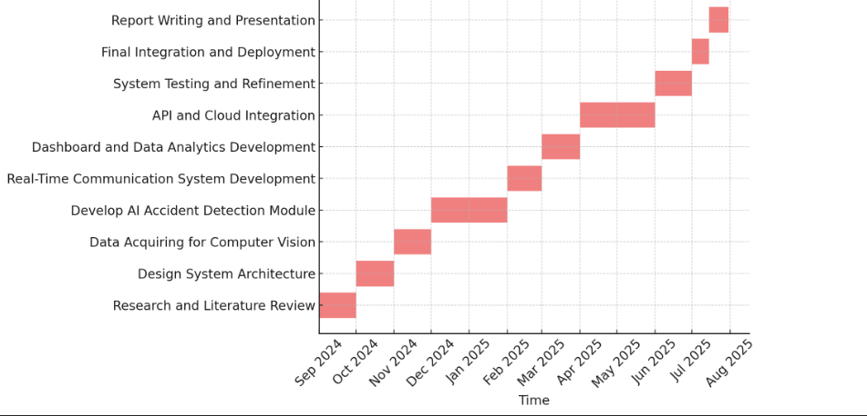
Project Plan / Project Schedule / Project Timetable / Project Calendar

Resources Required
The system will require road cameras, cloud computing platforms, and APIs for communication and Google Maps for geolocation. It will also make use of web development tools. Initial datasets to train the AI model will be obtained from open datasets.

References/Bibliography
- Kamran, S., & Haas, O. (2007). A Multilevel Traffic Incidents Detection Approach: Identifying Traffic Patterns and Vehicle Behaviors using Real-time GPS Data. 2007 IEEE Intelligent Vehicles Symposium.
- Škorput, P., Mandžuka, S., & Jelušić, N. (2012). Real-time detection of road traffic incidents. PROMET - Traffic Transportation, 22(4), 273–283.
- Ksiksi, A., Al Shehhi, S., & Ramzan, R. (2015). Intelligent traffic alert system for smart cities. 2015 IEEE International Conference on Smart City/SocialCom/SustainCom (SmartCity).
- Sadaphal, I. (2019). Accident detection and alert system using Android application. International Journal for Research in Applied Science and Engineering Technology, 7(5), 3466–3469​

